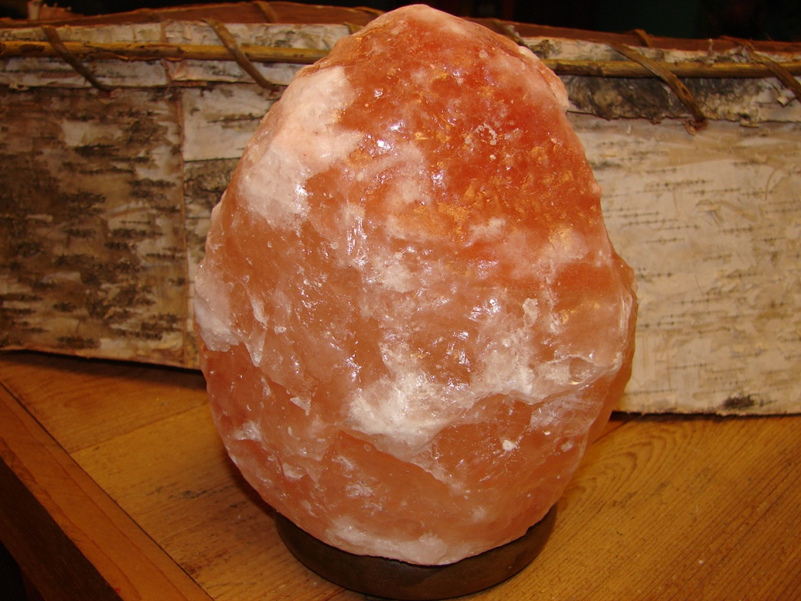

Himalayan Salt Lamp
$35.00
- These lamps are made of natural crystal salt mined from underground salt mines in the foothills of the Himalayan Mountains
- The beautiful orange-reddish Himalayan crystal salt is mounted on a wooden base
- This crystal salt is hundreds of millions of years old and, as a result, has special properties and high mineral content
- Heat from the bulb (in lamps) or flame (in candle holders) causes the salt to emit negative ions
- These negative ions bond with the pollutants in the air (positive ions) and neutralize them
- Also, the newly bonded ions become heavier and fall to the ground removing them from the air circulation
- In addition, these negative ions combat electro-smog caused by electronic devices operating in the home
- Symptoms from asthma, allergies, and other illnesses can also subside
- These products cleanse the air naturally and are extremely beautiful

For a more technical explanation of the workings of these products see the following explanation which was attained from the authoritative text "Water & Salt - The Essence of Life" by Dr. Barbara Hendel and Peter Ferreira.
Technical Explanation
Crystal Salt Lamps have big advantages, and not only for cleaning the environment of a room. Sitting in front of televisions or computer monitors, we are bombarded with an electro-magnetic frequency of around 100 to 160 Hz. (Hertz). Our brainwaves however, vibrate at around 8 Hz., a rate that equals the Schuhmann-Resonance-Frequency. This means that while watching TV or working at the computer, our body is exposed to frequencies that vibrate 20 times faster than our brainwaves. The result is a lack of concentration, nervousness, and insomnia.
Harmonizing Ionizing Effect
Crystal salt lamps bind the excessive positive ions with their negative ions. When they warm up, they attract humidity and the surface of the salt crystal becomes moist. This causes a field of ions to build. Crystal salt lamps can also neutralize the electro-smog in a room. Additionally, the various colors of the lamp have positive effects. The therapeutic wavelengths of the colors of these crystals fall within the upper nanometer zone (600 to 700 nanometers), which are visible to our eyes and effect a reorganization of the epidermal layer of the skin. The frequencies at this upper nanometer zone are also used in allopathic medicine for treating skin cancer. Furthermore, tests on hyperactive children with concentration and sleeping disorders (ADHD symptoms) have shown that using crystal salt lamps drastically reduces their symptoms after only one week. When the lamps were removed, their symptoms returned.
Scientific Studies
Several scientific studies show that salt crystal lamps can increase the negative ion count by up to 300%. In nature Negative Ions are created by means of wind, sunlight, surf, waterfalls, and rainstorms. Generally, a negative ion is an electronically charged molecule consisting of oxygen. A positive ion in the air is a molecule that has lost its electrons through process of air pollution. In fresh country air we find up to 4000 negative ions per cubic centimeter - the size of a sugar cube. Near strong surf or close to a waterfall up to 10,000 negative ions can be found, however the number of negative ions in major capital cities at rush hour does not even reach 100.
The impact of negative ions is powerful. Originally, it was found to speed recovery in burn and asthma patients, but was later discovered to affect serotonin levels in the bloodstream, stabilize alpha rhythms, and to positively impact our reactions to sensory stimuli. The greater level of alertness can translate into improved learning, improved well being, and enhanced human performance of mental tasks.
Ionized air also substantially reduces the number of airborne bacteria indoors. Dr. Albert P. Krueger, a microbiologist and experimental pathologist at the University of California, found that an astonishing small quantity of negative ions could kill bacteria and quickly take them out of the air so they were less likely to infect people.
Even though they are not a "medical device", Salt Crystal Lamps, by emitting negative ions, significantly reduce a myriad of indoor air pollutants. Negative ions have known benefits which may provide relief from sinus migraine headaches, allergies and hay fever. They may reduce the severity of asthma attacks, enhance the immune system, increase alertness, increase work productivity and concentration, increase lung capacity, and reduce susceptibility to colds and flu.
For ages humans have known about the positive forces of salt and its cleansing and neutralizing effects on our health. These 250 million year-old salt crystal lamps connect aesthetic shapes with health-promoting effects by creating a balance of ions in the air. They lend invigorating freshness, giving the sensation of being by the sea. Their colors create a harmoniously soothing warm environment. Each lamp has a unique form and color. All in all, these are attractive products that actually cleanse the air that we breathe.
Note:
Above information obtained from the book "Water & Salt" by Hendel and Ferreira. We are not scientists and cannot personally validate these findings, but they do come from the aforementioned reputable literary source. Also, we have had many customers write and call us saying that many of their allergy symptoms have improved. Also, please note that these are natural, organic products and that each vary in shape and size. Like snowflakes - no two are exactly alike.

