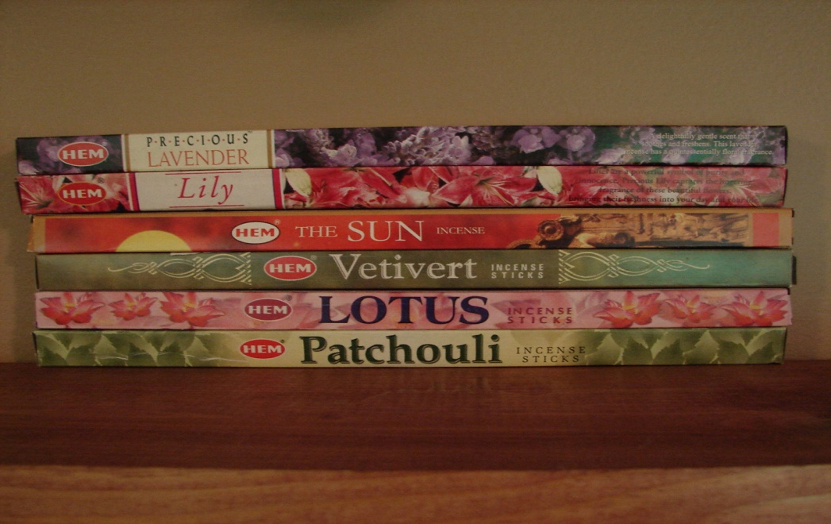
Incense
$2.00

HEM is world famous for its traditional incense made from select woods, resins, florals and fine essential oils all blended skillfully with expert care and love. Incense comes in a variety of floral, exotic wood and traditional resin fragrances.

Lavender - A delightfully gentle scent that soothes and freshens. This lavender incense has a quintessentially floral fragrance.

Patchouli - Feel the mystical richness of acclaimed Patchouli incense. It is a must for all special occasions

Sun - Light up your life with the universal energy source captured in this incense and recharge yourself.

Lilies - are a powerful symbol of purity and innocence. Precious Lily captures the lingering fragrance of these beautiful flowers, bringing their freshness into your day and your life.

Vetivert - was known in ancient India as sacred kusha grass. The strongly aromatic roots of the vetivert plant produce an exotic vanilla/amber-like fragrance.

Lotus - the flower of yoga. Live in peace and harmony in mind, body and spirit.

