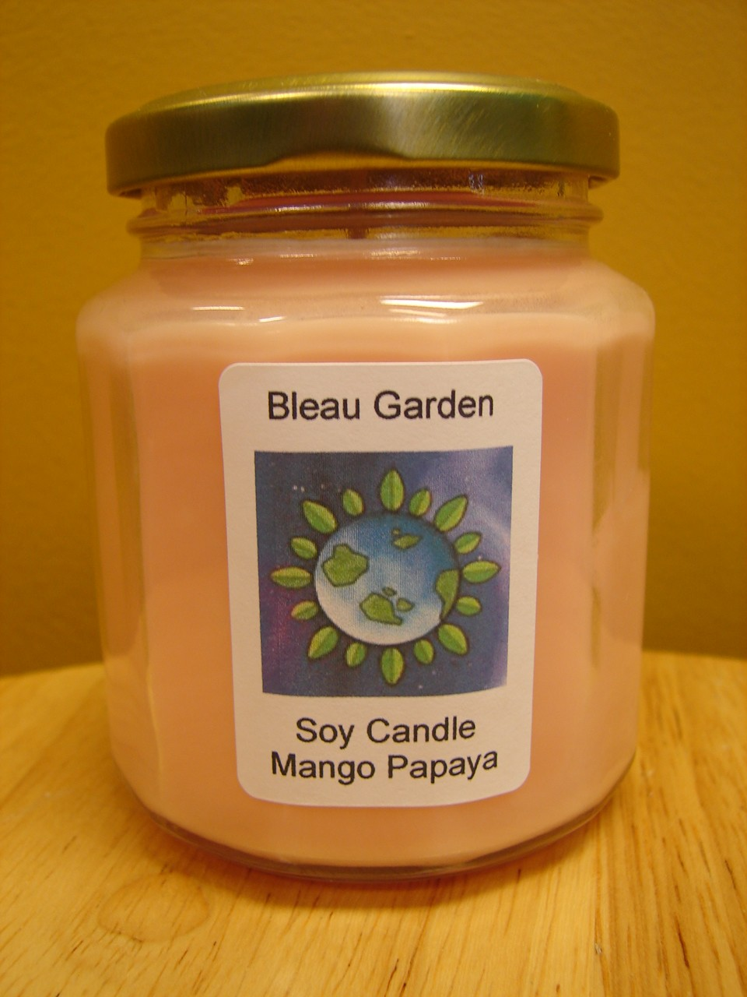

THE BENEFITS OF SOY CANDLES
The following list identifies a number of reasons why soy wax candles are preferable to paraffin wax candles:
- No carcinogens are produced from burning soy wax.
- Soy wax is non-toxic.
- Little or no soot is produced from burning soy wax.
- Soy wax will not discolor your walls or furniture with petroleum byproducts.
- Soy wax is a renewable resource; petroleum is limited.
- Soy wax is biodegradable.
- Soy wax is water-soluble (no more messy cleanups).
- Burning soy wax candles helps support the American farmer.
- Soy wax holds color and scent better than paraffin.
- Soy wax burns 30% to 50% longer than paraffin.

