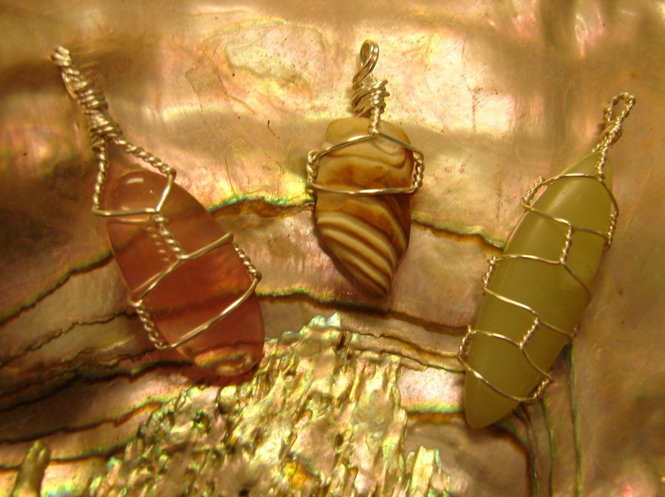
Wire Wrapped Pendants
$8.00

AGATE-TURRITELLA:
Emotional trauma; self-confidence; concentration; perception; analytical abilities; aura stabilization; negative-energy transformation; emotional disease; digestive process; gastritis; eyes; stomach; uterus; lymphatic system; pancreas; blood vessels; skin disorders

CARNELIAN: Stone associated with emotional warmth, creativity, reproduction, rebirth, reincarnation and past life recall. Calms mind from fear of death and enforces belief in cycle of birth-death. Excellent motivator in matters of business and career-choices. Brings day-dreamers and absent minded professors to ground zero. Carnelian directly works on lower chakras, so it dispels arthritis, rheumatism, lower back troubles, female reproductive problems, increases fertility and cures impotence. Alleviates blood poisoning, nose bleeds, wounds, sores, spasms and all ailments related to blood; besides being a remedy for fever, neuralgia, allergies and infection.
CHRYSOCOLLA:
Ease heartache, Earth healing, calming, inner strength, PMS, menstrual discomfort, relieve allergies, treat ulcers, digestive problems, arthritis, lungs and thyroid, enhances the metabolism, psychic ability, prophetic dreaming, trance, increase the ability to love, improve home life and strengthen relationships.

FLUORITE:
Stone associated with enlightenment and healing on all the three planes – spiritual, mental and emotional. Diminishes stress and aids in spiritual awakening. Cleanses, balances and focuses energies on all levels of chakras. Grounds and protects aura from leakage of energy. On the physical body, it heals ailments of bones. Alleviates arthritis, strengthens bone tissue especially teeth enamel and relieves dental disease. Ancient cure for cancer. Also responds well to hormonal balance and hormonal changes like PMS, menopause. Arouses sexual energy. Quickens healing from pneumonia and viral inflammation.

HEMATITE:
A natural ferric oxide and iron-ore, Hematite possesses exceptional grounding abilities. Helps you be at ease and keep nervousness at bay. Also a protective stone, whenever you feel the need for protection and face challenge in panicky situation, carry a Hematite stone with you. It could be crucial meetings, interviews or legal matters – a must for lawyers, as it also aids memory. On a spiritual plane, it enhances astral projections, promotes balance, focus, convergence and concentration of energy. Helps increase courage and will-power. Medically, it is good for kidneys and heart – for high BP patients it reduces rapid pulse; helps coagulation and purifies blood.

JADE:
In ancient Egypt and even now in Japan & China, Jade is considered the most precious of all stones. It is credited with five qualities: clarity, courage, justice, wisdom and modesty. It is one stone that oozes tranquility. So much so, even holding a Jade in your hand may cause you to experience a feeling of serenity or wisdom. Consequently, it also helps in smooth transition to another world and aids in peaceful death. It assists in taking control of dreams, and making sense of them. Use Jade to reduce tension in your life. Protects one from enemies and during long journeys. Physically, cures kidney problems, bladder troubles, poor digestion and eye problems. Alleviates sore back or spine.
JASPER:
Jasper is a wonderful supporting stone. Wear it to gain a positive outlook. Attracts what one needs (not wants). Good for those needing more organizational abilities. Mood elevator, invigorating, stabilizing and helps overcome depression. Improves the sense of smell and soothes the nerves. Useful in overcoming disorders of blood, digestion, stomach, biliousness and bladder trouble.
QUARTZ:
Clearly, the best all purpose stone! The symbol of elemental wholeness, containing the four elements of creation. Assists us to amplify, focus, direct, transmit and store energy. Its greatest attribute is known to be its use as an aid to opening the psychic centers, enabling the ability to meditate at a deeper level and to free one's mind from the mundane and the trivia. It releases the higher consciousness and develops mystical and spiritual gifts. It is also particularly useful for meditation and when working to contact or align with one's higher self! The Quartz Crystal attracts the powers of light and energy and is said to be an excellent powerful general healer and dynamic working tool which works on all levels - strengthening, cleansing and protecting. Purifies air. Protects against harmful electrical vibrations. Assists the wearer to think intuitively.
ROSE QUARTZ:
Rose quartz is highly recommended for those who are experiencing a lot of grief. Very good for expressing and soothing emotions. Rose quartz is a very loving stone, and enhances all forms of love: self-love, mother love, caring, kindness, platonic and romantic live. Gently energizes and creates warmth. It is also said to stimulate the imagination and the intellect and to open up the heart to inner peace, self love and self recognition. It is a very healing stone for internal wounds, bitterness and sorrows. It makes one more receptive to beauty, hastens recovery and gladdens the heart. Lifts depression, creates confidence and peace. Helps the heart and circulatory system. This lovely stone is claimed to be one of the best stones to use in the treatment of migraines and headaches of all types.

SODALITE:
Sodalite protects from external negative energy and is a highly grounding stone. If you use computers too much, wear it to shield against damaging effects of the radiation. Sodalite's color symbolizes wisdom and psychic activities. Fosters rational thinking, logic, intelligence, emotional balance, intuition, higher knowledge, clarity, truth and perception. It also soothes and heals the central nervous system. Sodalite clears the mind for deeper and wiser thinking, aids logic along with opening third eye intuition, stabilizes mental processes and aids in the shift from emotional to rational thinking. Use it if you are a person who over reacts emotionally or has panic attacks. Helps to eliminate confusion, change habits and stimulate ones intellect. Physically, it lowers blood pressure and balances the metabolism. Assists in sleep.
TIGER EYE:
Tigers eye is a stone used for courage, confidence and protection. It is also a solar plexus stone, and helps by deepening perception and clarity of self, and giving us courage when we need it most. It is good for manifesting of ideas and to place visualizations into reality. It helps us to obtain goals by taking direct action and by learning when to act or wait. It is claimed that tiger eye will counteract feelings of hypochondria and the onset of psychosomatic illness and will also give a feeling of self-confidence. It is especially good for clear thinking and helps one to see a problem objectively when confused or emotionally affected. Protects from witchcraft and evil. Also associated with the correct use of power, courage, grace and the ability to see clearly and without illusion. Excellent for asthma patients.
TOURMALINE:
Comes in various colors and hues. Balances, protects, calms, gives self- confidence and cheerfulness. Useful for meditation. Attracts inspiration, goodwill and friendship. Protects wearer against misfortune and anemia. Prevents lymphatic disease. Grounds high-frequency energies. Black or Green Tourmaline strengthens nervous system, regulates blood pressure. Deflects negative energy, attracts prosperity. Blue Tourmaline cures all throat problems, thyroid and speech impediments. Promotes clear verbal expression, dissolves mental friction, emotional constriction. Carries a high electrical charge and if rubbed briskly one end becomes positive and one negative, the energy can then be directed wherever peaceful energy is required. Watermelon/Pink Tourmaline is a heart balancer. Promotes understanding of self and emotions. Enhances flexibility, happiness, objectivity, compassion, serenity, balance, positive transformation, healing, strength, tolerance, and understanding. Excellent channeling stone for communication with higher forces.

